

**Bachelor of Science in Computing**

**School of Public Administration**

**Macao Polytechnic Institute**

**COMP 492 Final Year Project**

**Project Proposal**

|  |  |
| --- | --- |
| **Indoor Helper Robot** | |
|  |  |
| Project Number: | 29 |
| Student Name: | Key, Liang Yijuan  (p1107923) |
|  |  |
| Supervisor: | Dr. Cora Lai |
| Assessor: | Dr. CT Lam |
|  |  |
| Submission Date: | 2014/09/11 |

Contents

1. Main tasks and Objectives 3

2. Project Description 3

3. Summary of Related Work and Key References 4

4. Project Workplan 4

5. Risk Assessment 5

6. Reference 6

# **1. Main tasks and Objectives**

The main task of this project is to develop and control an indoor navigation robot which can go to a desired place within a room area and do the delivery as a helper. This robot can move following the color line and fetch objects and do delivery. LEGO® MINDSTORMS® EV3 is chosen as the development model.

The following functions should be developed with the robot in this project:

* Move from starting position to different destinations
* Move according color lines
* Turn left or right correctly
* Go back to start area after reaching the destination
* Read NFC tags to recognize places
* Fetch/deliver (?) objects

# **2. Project Description**

In this project the following tasks should be done before the end of next semester.

* Study related works
* Experiment how to place the different sensors
* Experiment how to place NFC tags
* Experiment fetch/deliver (?) different objects
* Design fuzzy logic for movement
* Recognize different color and run action correctly
* Develop a moving road database
* Design the program
* Implement the program
* Writing the report

The following table shows the scope of this project:

|  |  |
| --- | --- |
| Function Provided | My project |
| Color sensing | **√** |
| NFC positioning | **√** |
| Move following the line | **√** |
| Fetch objects | **√** |
| Deliver objects | **√** |
| Move in a room | **√** |
| Move in the same floor | **×** |
| Move in different floor  **Figure 1 Project scope** | **×** |

As confined by the Bluetooth signal range, the robot in this project will move in room A322 in MPI, but not move around the whole floor. In the very beginning, this EV3 robot will move on a whiteboard following color lines drawn with highlight pens.

# **3. Summary of Related Work and Key References**

As the development of technology, human interactive robot development has been a big topic in the world. Developing a robot helper instead of human do by themselves has been a trend of people’s interests. Fuzzy logic [1] design, which is introduced in 1960s, will be also used as other similar robot projects. LEGO® MINDSTORMS® EV3 programmable robot is chosen for this project because it is small enough to move and carry. Also, spare parts are available to be used to develop extra original modules too. And this EV3 robot also supports different kinds of connection means including Wi-Fi (but this requires an added Wi-Fi adaptor). Therefore, it is well famous to be selected in similar kinds of projects.

# **4. Project Workplan**

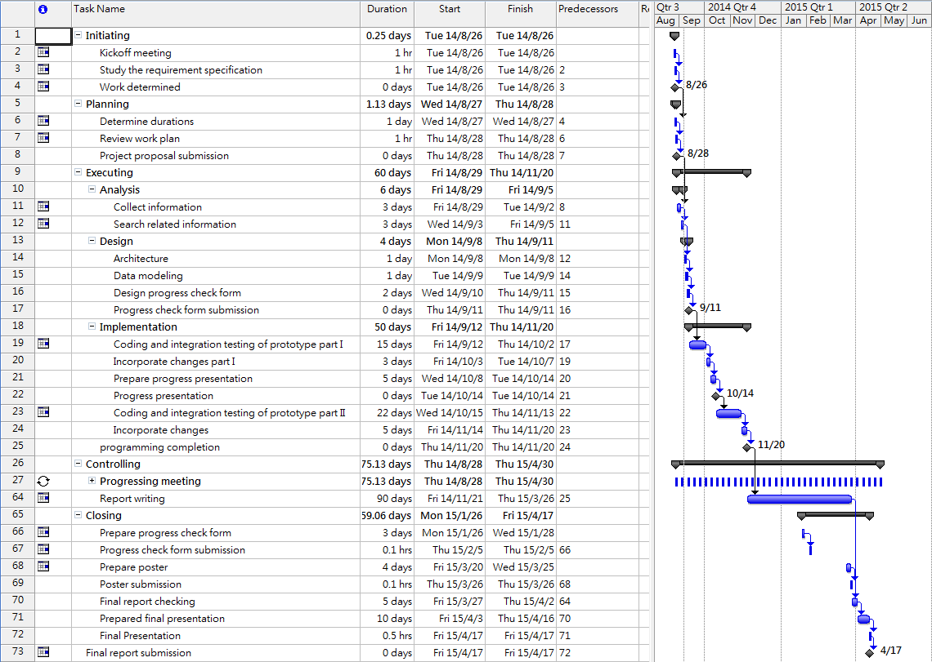The schedule of all the works are shown in Figure 2

# **5. Risk Assessment**

**Figure 2 Work plan**

During the process, there are four possible risks may occurs, namely battery running out, connection setup disabled, harddisk damage and data lost and motor out of function.

* Battery running-out
  + Firstly, there is a potential risk that battery runs out during the testing period. This will lead the robot unable to move properly. Also, as movement control is designed to use set power volume if bthe attery cannot provide enough power the moving distance may be affected. Therefore, full-charged backup batteries are prepared.
* Connection setup disabled
  + Secondly, as there are too much radio signals in the campus, Bluetooth connection may be interfered. This makes it impossible to set up the connection between the computer and the robot. If this happens, it is tested to be feasible to move to another place, for example the rooftop, to reset the connection. The connection set up process can be performed at the rooftop of the teaching building, as there is less interferes. Once the connection is set up it will not be disconnected until disconnect operation is triggered, and after connection set up, everything can be move back to the lab and resume its normal operation.
* Hard disk damage and data lost
  + Thirdly, all the develop programs or documents may lost due to hard disk problem. Therefore, besides saving data in the local computer, at least one copy backup will be placed in a USB and a backup copy will be put in the network. Once developement data is lost, backup data will be used to continue the project. Furthermore, all the updates will be done on a new copy of the previous version so that once update is incorrect, the older version can be found immediately.
* Motor out of function
  + Last but not least, In case of accident, motor of the robot may be out of function. This might stop the robot from moving. If this happen, it is necessary to replace motor with a backup that is in place .

# **6. Reference**

[1] Wikipedia, <http://en.wikipedia.org/wiki/Fuzzy_logic>, [Sept 09, 2014]